Christmas Tree Safety
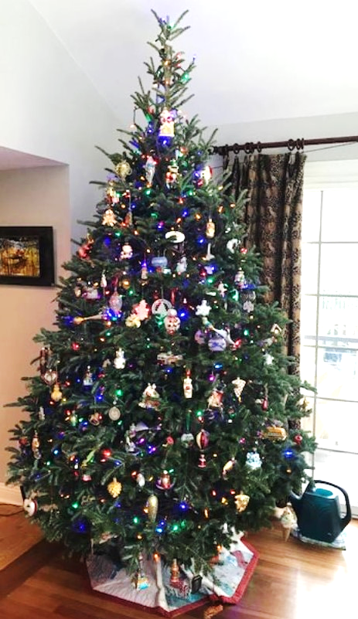
The YouTube link below shows how fast a Christmas Tree that has not been watered can burn. A tree fire produces extremely hazardous conditions, that can result in loss of life and property in only a matter of seconds.
As you watch the video, observe how fast the fire spreads for the tree, traveling upward to the ceiling expanding in volume and spreading within the room. Temperatures can reach 1300F degrees at the ceiling. If your tree is in an open design space, the fire will continue to grow and travel up stairwells and into rooms with open doors. If the tree is confined to an enclosed room, the fire will continue to grow until the fuel is consumed causing the fire to become fuel and oxygen starved. The room visibility will blacken, and temperatures can be 1000F degrees from ceiling to floor creating a deadly environment.
- Almost one third of home Christmas Tree fires are caused by electrical problems
- Although Christmas Tree fires are not common, when they do occur, they are more likely to be serious
- A heat source too close to the tree can causes more than one in every five of the fires
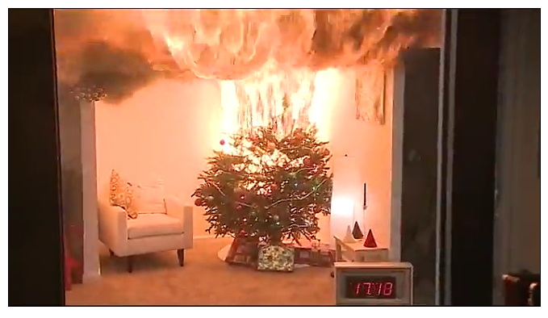
NFPA Christmas Tree Video
https://youtu.be/xr6b9b8FYKk

Please:
- Make sure the smoke and CO alarms are in good working order
- Make sure the tree is at least 3 feet from a heat source and not blocking an exit
- Check light strings for worn or broken cords
- Water the tree daily
- Turn off the tree lights when not at home or when sleeping
- Have all bedroom doors closed while sleeping
- Review options on how you plan to exit your home during a fire
- Dispose of the tree when it dries-out
Stay safe and have a wonderful holiday season.

